Dual Booting Exercises Unit 2

Create a document with screenshots to explain the answer for each

exercise

1. Create a virtual machine with two operating systems, Windows 7 and Windows 10

(in this order). Choose Windows 7 as the default operating system, which will boot

after 5 seconds unless Windows 10 is manually selected.

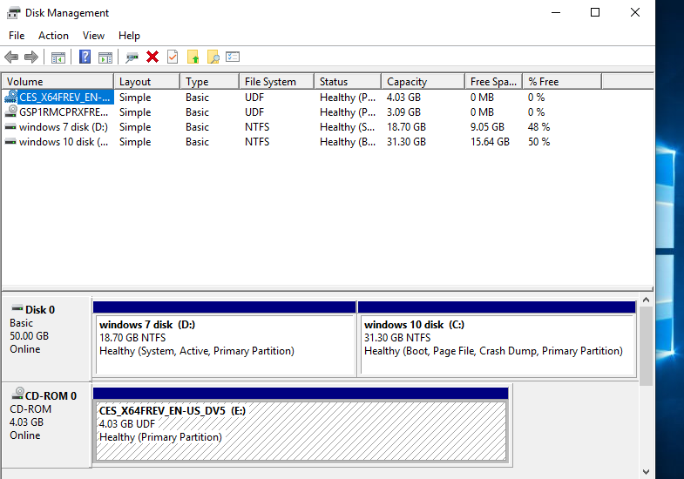

IN DISK MANAGEMENT WE CAN SEE THE TWO PARTITIONS CREATED FOR EACH OPERATING SYSTEM AND NOW WE WILL CONFIGURE THE SYSTEM TO HAVE A WINDOWS 7 MENU INSTEAD OF THE WINDOWS 10 OPTION.

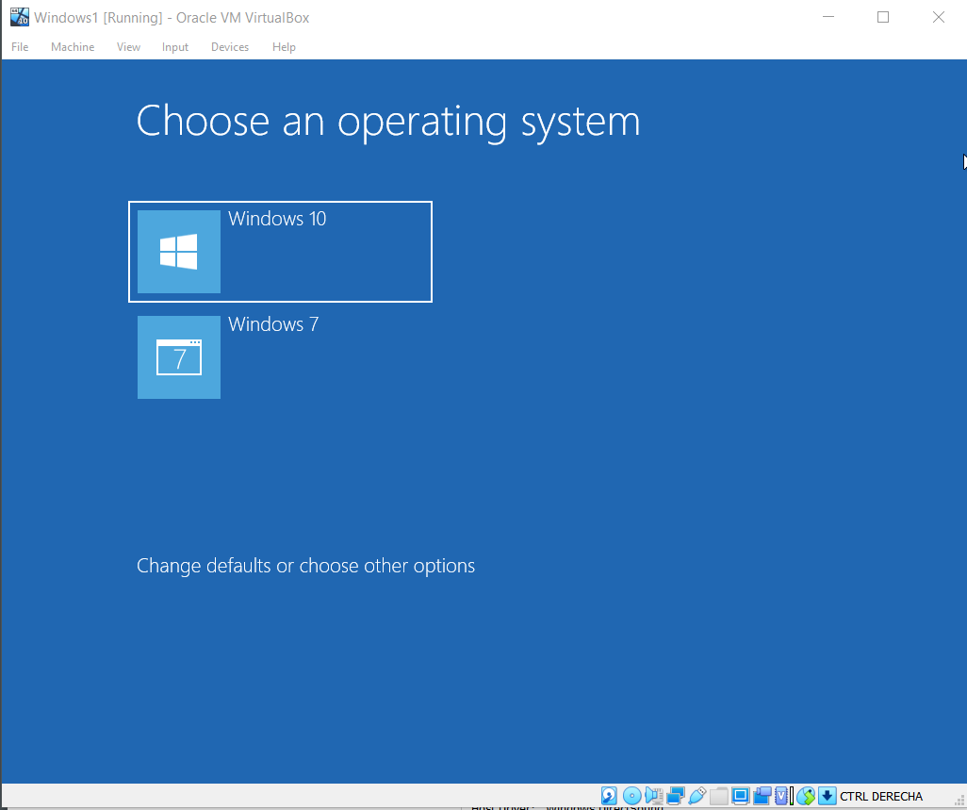

WE ARE GPONG TO SELECT THE CHANGE DEFAULTS AND OTHER OPTIONS.

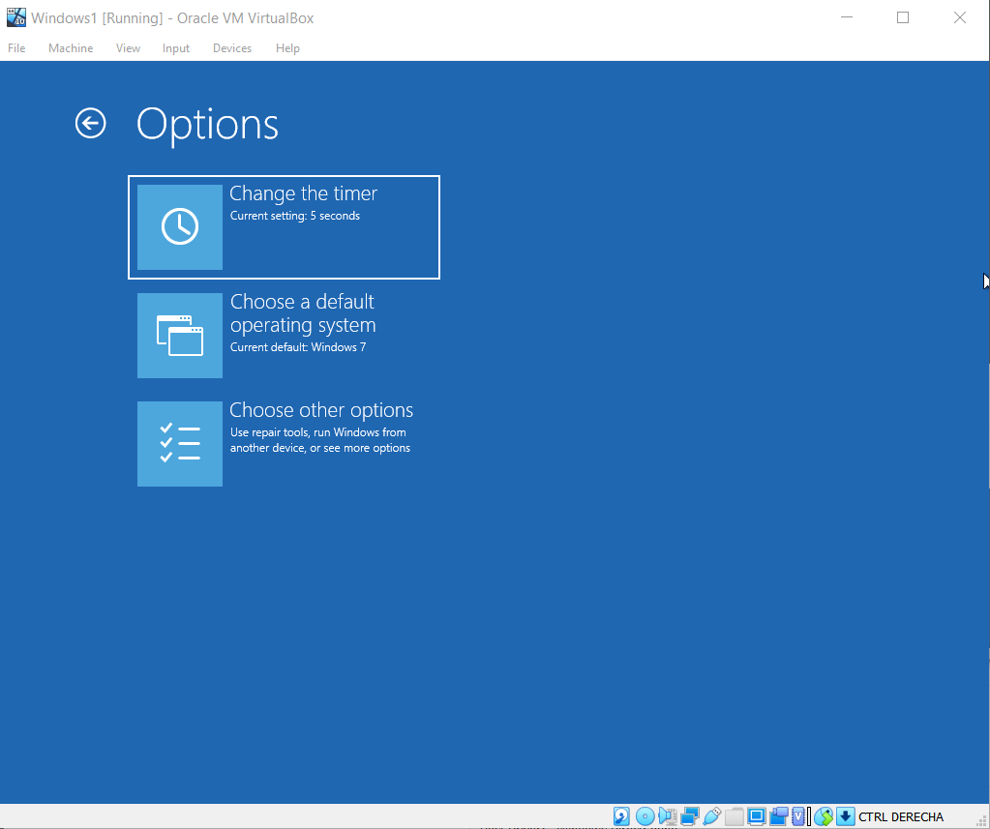

ACCORDING TO THE RECQUIREMENTS, WE HAVE SELECTED A 5 SECOND BOOT AND WE HAVE CHANGED THE DEFAUT OPERATING SYSTEM TO WINDOWS 7.

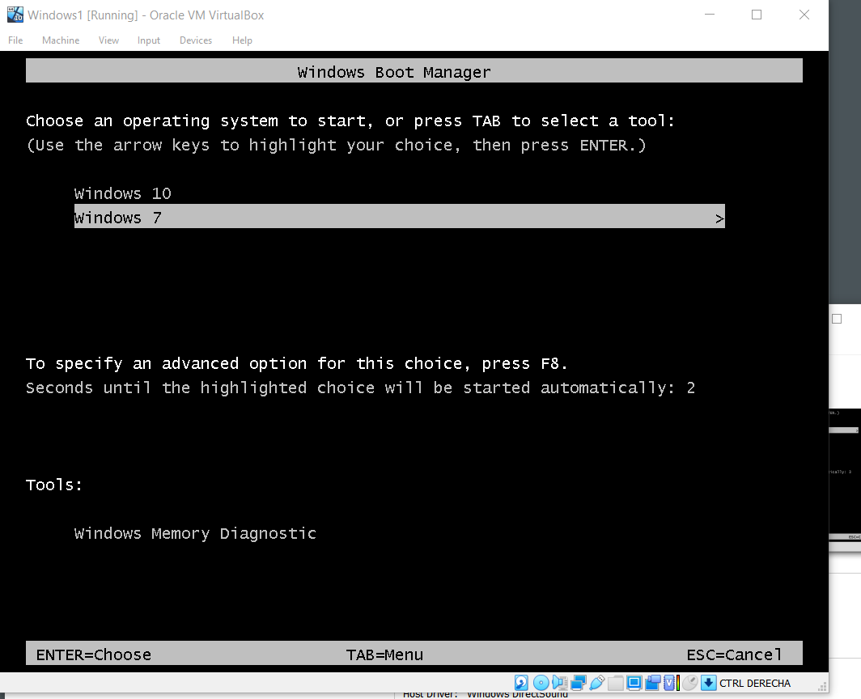

THIS IS THE WINDOWS 7 MENU THAT STARTS AFTER 5 SECONDS AUTOMATICALLY.

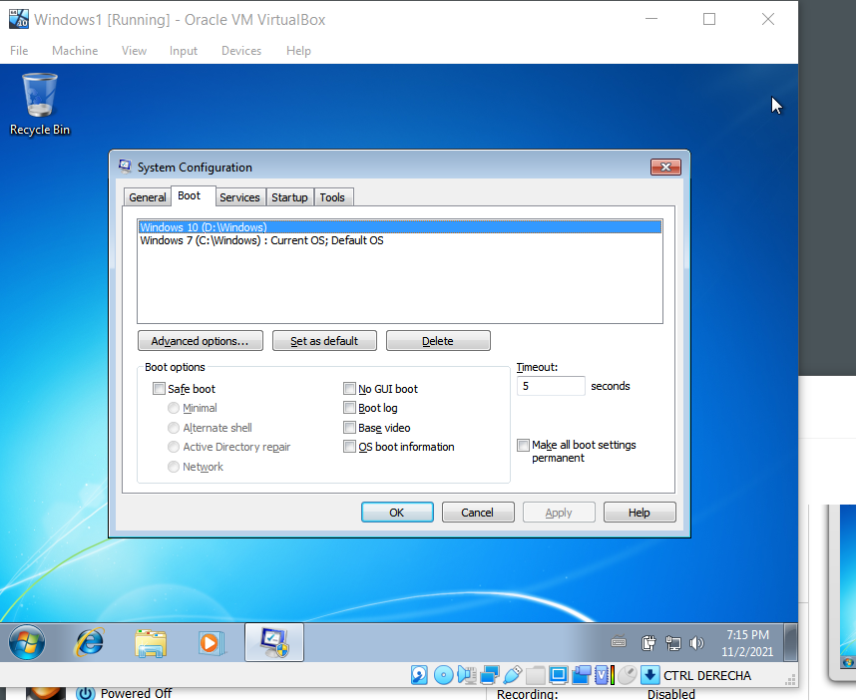

IN SYSTEM CONFIGURATION WE CAN ALSO CHANGE THE SETTINGS THAT WE NEED.

2. Create a virtual machine with two operating systems, Windows 7 (or Windows 10)

and Ubuntu 20.04 (in this order) and configure the bootloader to:

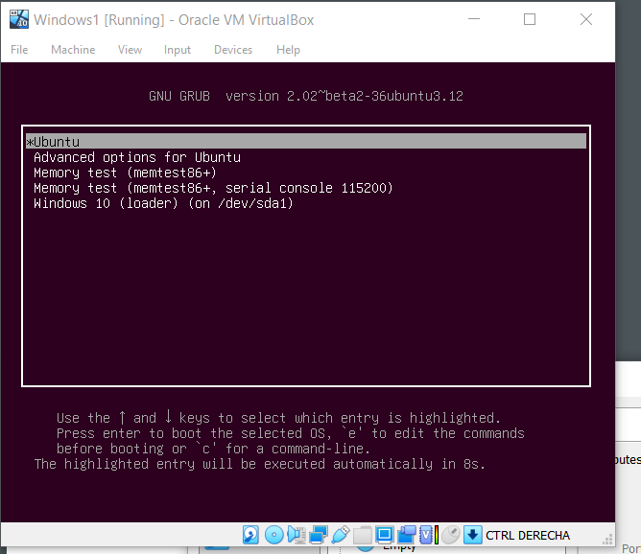

WE HAVE INSTALLED UBUNTU IN THE VM AND NOW WE HAVE THE BOOT MENU TO START CONFIGURING.

a. Set Windows as default entry and boot after 15 seconds if the user does not

select another option in the menu.



UBUNTU = 0 ADVANCED OPTIONS = 1MEMORY TEST =2 MEMORY TEST =3 WINDOWS LOADER=4. WE NEED THIS TO CHANGE THE PARAMETER IN THE GRUB.CFG FILE.

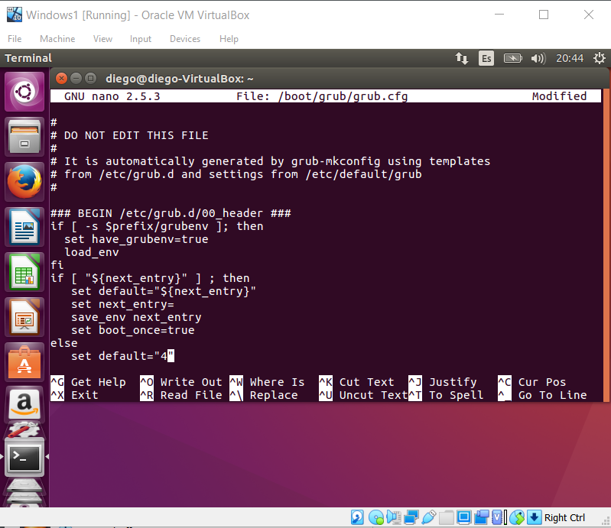

THE SET DEFAULT OPTION IS SET ON 4 SO THAT WHEN THE COUNTDOWN FINISHES, WE GET A WINDOWS BOOT INSTEAD OF UBUNTU.

b. Boot Ubuntu without displaying the menu after showing a 10 seconds

countdown.

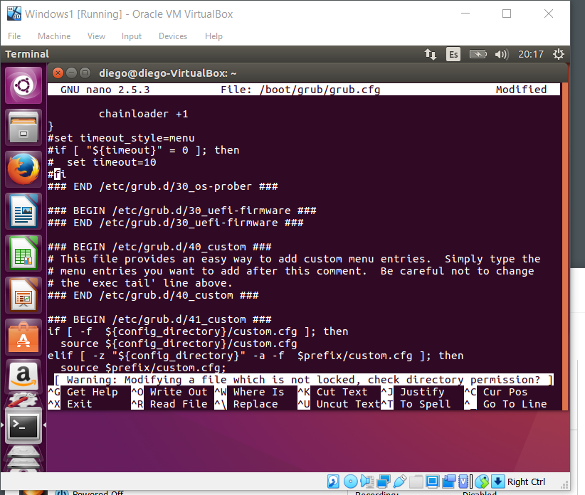

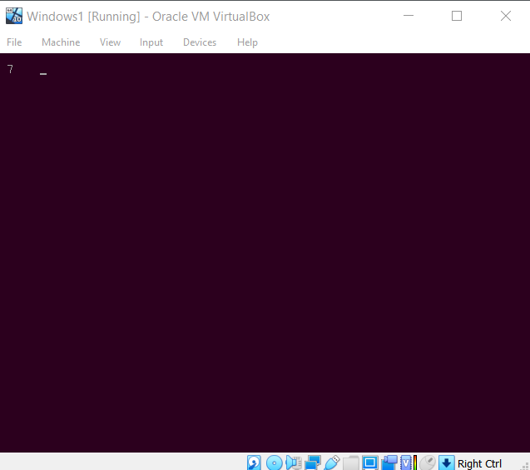

WE GO INTO NANO TO EDIT THE GRUB CONFIG FILE AND PUT # IN THE CIRCLED COMMANDS IN ORDER TO “TURN THEM OFF”. ALSO, WE NEED TO CHANGE THE TIMEOUT STYLE TO COUNTDOWN IN ANOTHER LINE AND YOU GET THE COUNTDOWN WITHOUT THE MENU. THE PICTURE SHOWS THE TIER ALREADY AT 7.

c. Boot Ubuntu without displaying the menu.

WE JUST NEED TO CHANGE SIMILAR THINGS TO GET SIMILAR RESULTS. IF WE WANT TO BOOT UBUNTU WITHOUT A MENU FOR OPTIONS WE NEED TO CHANGE THE FOLLOWING PARAMETERS IN THE GRUB.CFG FILE:

GRUB_DEFAULT=0

GRUB_TIMEOUT=0

GRUB_TIMEOUT_STYLE=hidden

d. Boot Windows without displaying the menu.

AGAIN THE IDEA IS SIMILAR BUT WE HAVE TO CHANGE THE FOLLOWING:

GRUB_DEFAULT=4

GRUB_TIMEOUT=0

GRUB_TIMEOUT_STYLE=hidden

3. If you lose the bootloader in exercise 2, use the tool “Boot-Repair”, which will let

you solve the issue. If necessary, use the following the instructions in the URL:

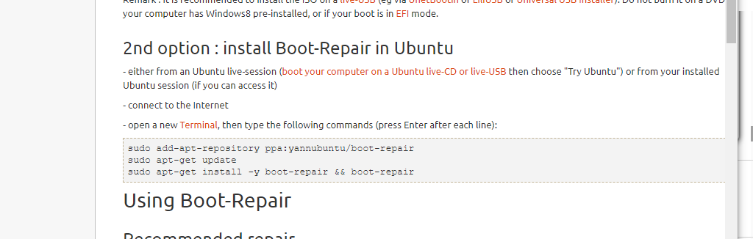

WE ARE GOING TO INSTALL BOOT REPAIR WITH THE FOLLOWING COMMANDS IN THE TERMINAL IN ORDER TO RECOVER GRUB TO ITS ORIGINAL SETTING IN CASE WE CHANGED SOMETHING WE ARE NOT MEANT TO.

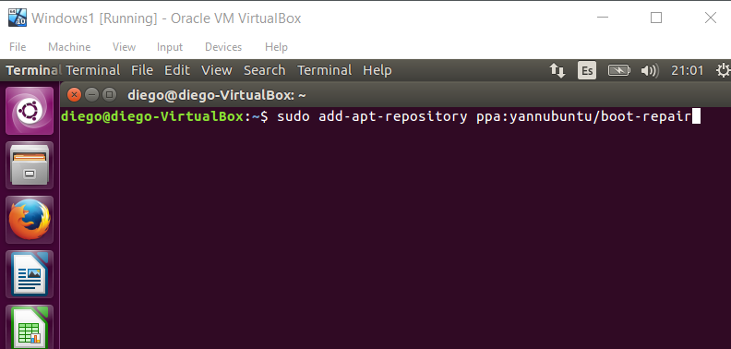

https://help.ubuntu.com/community/Boot-Repai